Decision Matrices, Justification & Component Selection

Executive Summary: Component Selection & Justification
- Structural: We selected OVERTURE PETG Filament (White/Grey) for the tower body. Unlike PLA, PETG offers superior hydrolysis resistance and layer adhesion, preventing leaks in the 100% humidity chamber.
- Rotation: To handle the 40kg axial load, we chose a Heavy Duty Steel Lazy Susan (500lb capacity) driven by a JGY-370 12V Worm Gear Motor. The worm gear provides inherent self-locking, preventing back-driving without complex brakes.
- Misting: The Mxmoonant 3-Head Ultrasonic Fogger (1500ml/hr) was selected to generate "dry fog" (5-10µm droplets). It will operate on a 50% duty cycle with distilled water to maximize component lifespan.
- Control: An Arduino Uno R3 Kit (5V logic) was selected for its native compatibility with relays and sensors. A 12V 2A Power Supply provides a 1.5x safety factor for the system's peak current draw.
Comprehensive decision matrices, detailed engineering computations, and specific validation protocols supporting these component selections are provided in the subsequent sections of this report.

1. Structural Subsystem Design & Selection
This section details the selection of materials for the tower body (modules) and the central support spine.

1.1 Decision Matrix: Material Selection
We evaluated materials based on Water Resistance (hydrolysis resistance), UV Stability (exposure to grow lights/sun), Printability (warping risk), and Mechanical Strength.

Material | Water Resistance | UV Stability | Printability | Strength/Durability | Score (1-5)
PLA | Low (Biodegrades/Swells) | Low (Brittle over time) | High (Very Easy) | Medium | 2/5
ABS | High | Low (Yellows/Cracks) | Low (Warps easily) | High | 3/5
PVC (Pipe) | High | High | N/A (Purchased) | High | 5/5
PETG | High (Hydrophobic) | High | High (Low shrinkage) | High (Flexible) | 5/5 (Modules)

1.2 Justification
- PETG for Tower Modules: Selected as the primary structural element. Aeroponic systems are 100% humidity environments. PLA absorbs moisture and degrades. PETG is hydrophobic, UV resistant, and prints with superior layer adhesion, which is critical since the tower modules themselves will support the vertical load.
- PVC for Pipe: Selected for alignment and water distribution only. It provides a straight guide rail to keep modules stacked vertically and serves as the conduit for pumping water to the top. It is chemically inert, ensuring no leaching into the nutrient solution.
1.3 Computations: Buckling Analysis of PETG Tower Body
To ensure the printed PETG tower modules do not buckle under the weight of wet plants and water, we analyze the tower as a thin-walled hollow cylinder.
Assumptions:
- Load (P): 40 kg (Conservative estimate for full water + mature biomass) ≈ 392 N.
- Material: PETG (Polyethylene Terephthalate Glycol).
  - Elastic Modulus (E): ≈ 2.0 GPa (2 × 10⁹ Pa).
- Geometry (Tower Body):
  - Outer Diameter (D_outer): 250 mm (0.25 m).
  - Wall Thickness: 2 mm (0.002 m).
  - Inner Diameter (D_inner): 246 mm (0.246 m).
  - Height (L): 1.5 m.
- End Condition: Fixed-Free (K = 2). The base is fixed to the rotator, top is free.
Step 1: Moment of Inertia for the PETG Cylinder
The large diameter of the tower modules provides a massive Moment of Inertia compared to a thin pipe, making it extremely stiff.
- Formula: I = (π / 64) × (D_outer⁴ – D_inner⁴)
- Calculation:
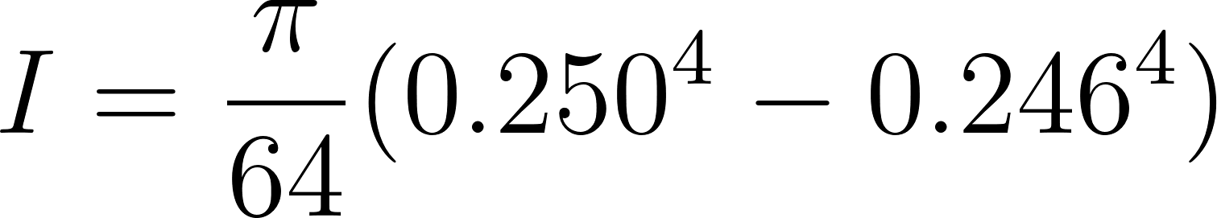
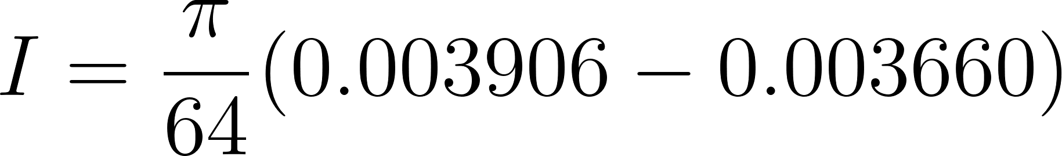
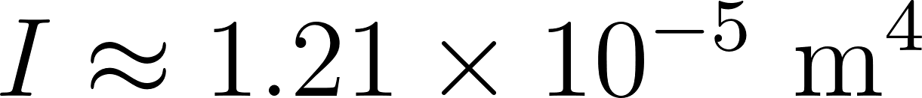
Step 2: Critical Buckling Load
- Formula: P_cr = (π² × E × I) / (K × L)²
- Calculation:
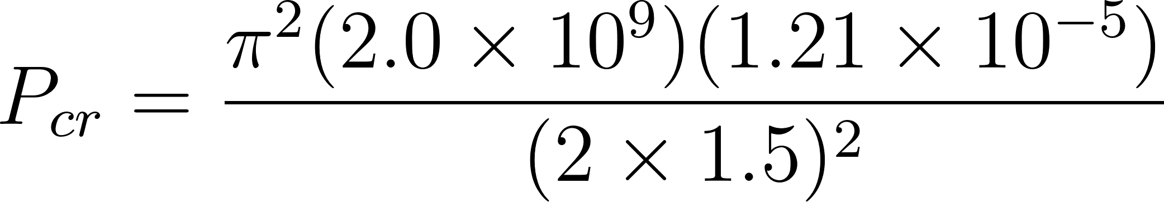
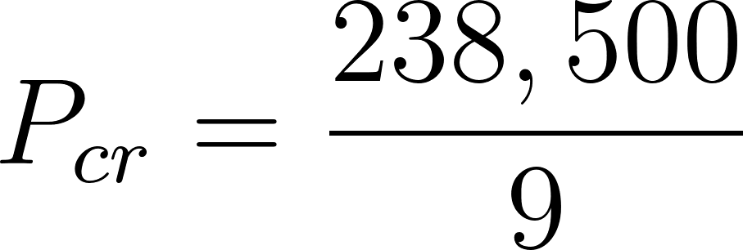

Step 3: Factor of Safety (FoS)
- Applied Load: 392 N
- Critical Load: 26,539 N
- FoS Calculation: 26,539 / 392 FoS ≈ 67.7
Conclusion:
The PETG tower body is structurally sufficient to support the vertical load with a massive safety margin. The central PVC pipe does not need to bear axial load, and metal reinforcement shafts are unnecessary. The primary failure mode to watch for is Layer Delamination (Tensile Failure) if the tower leans, not buckling.

1.4 Validation Plan
- Water Tightness Test: Fill printed PETG modules with water and let stand for 24 hours on a paper towel. Pass = 0 wet spots.
- Lean Stability Test: Assemble the full 1.5m tower without water. Apply a 5N horizontal force at the top (simulating accidental bumps). The tower must return to vertical without cracking layer lines.

2. Rotation Mechanism Design & Selection
This section details the selection of the drive system and bearing assembly required to rotate the tower. The rotation ensures even light distribution for all plants, which is critical for uniform growth in an indoor setting.
2.1 Decision Matrix: Drive & Support System
We evaluated options based on Torque Capacity, Complexity (parts count), Cost, and Smoothness (low jerk).
Drive System | Torque Capacity | Complexity | Cost | Smoothness | Score (1-5)
Direct Drive | Low (unless expensive) | Low | High | Low (Cogging) | 2/5
Belt Drive | Medium | Medium (Pulleys) | Medium | High | 4/5
Worm Gear Drive | High (Multiplies torque) | Low (Integrated) | Low | Medium | 5/5 (Selected)

Bearing Type | Axial Load Capacity | Precision | Cost | Friction | Score (1-5)
Roller Bearing | Low (for size) | High | High | Very Low | 3/5
Lazy Susan | Very High | Low (Acceptable) | Low | Medium | 5/5 (Selected)
2.2 Justification
- High-Torque 12V DC Gear Motor (Worm Gear): Selected because vertical towers rotate very slowly (1-2 RPM). A worm gear inherently prevents back-driving (the tower won't spin freely when power is off) and multiplies torque significantly, allowing us to use a smaller, cheaper motor.
- Lazy Susan Bearing: Selected for its ability to support high axial loads (the weight of the heavy water-filled tower pressing down). According to Agrotonomy (experts in aeroponic tower systems), the primary mechanical challenge is the vertical weight of the wet biomass and water, which a turntable bearing handles most efficiently.
2.3 Computations: Torque & Motor Sizing
To select the correct motor, we must calculate the required torque. The motor must overcome the Moment of Inertia (resistance to spin) and, more importantly, the Friction Torque of the bearing under load.
Assumptions:
- Total Mass (M): 40 kg (Conservative estimate: Water + Plants + Structure).
- Tower Radius (R): 0.15 m.
- Bearing Radius (r_b): 0.075 m (Typical 6-inch Lazy Susan).
- Friction Coefficient (mu): 0.05 (Estimate for greased stamped steel Lazy Susan).
- Target Acceleration (alpha): Reach 2 RPM (0.21 rad/s) in 2 seconds.
Step 1: Moment of Inertia
Model the tower as a hollow cylinder.
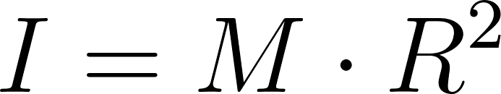
Step 2: Inertial Torque
Torque required to start spinning from a stop.

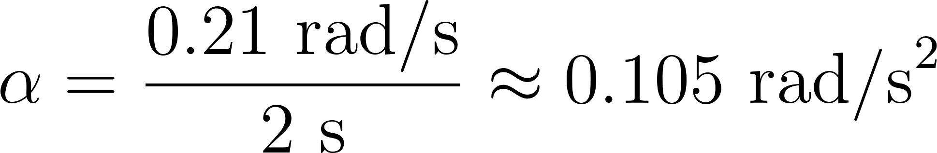
(Note: This is negligible compared to friction.)
Step 3: Friction Torque
Torque required to keep the tower moving against the heavy bearing load. This is the dominant factor.
Step 4: Total Required Torque
Conversion to kg-cm: 1.57 N-m ≈ 16.0 kg-cm
Conclusion:
We require a motor with at least 16.0 kg-cm of continuous torque.
Motor Selection: We have selected the Jersvimc JGY-370 12V DC Worm Gear Motor (6 or 10 RPM version).
Reasoning: This motor features a self-locking worm drive that prevents back-driving under the tower's 40kg load. While rated for 10 RPM, we will utilize Pulse Width Modulation (PWM) via the Arduino motor driver to reduce the speed to the target 2 RPM, increasing torque margins and smoothness.

2.4 Validation Plan
- Stall Test: Secure the tower base and power the motor to ensure the gearbox does not slip or stall under a simulated 40kg load (using gym weights).
- RPM Stability Check: Mark the tower and time 10 full rotations. The variation per rotation should be less than +/- 5%.
- Jerk Analysis: Visually inspect the start/stop sequence. The tower must not sway >2 degrees during acceleration to prevent water spillage.

3. Misting System Design & Selection
This section details the selection of the atomization method used to deliver nutrient solution to the plant roots. The unique constraint of the HELIX project (a rotating tower) heavily influenced this selection.
3.1 Decision Matrix: Atomization Method
We evaluated options based on Droplet Size (absorption efficiency), Plumbing Complexity (feasibility with rotation), Noise, and Clogging Risk.
Method | Droplet Size | Plumbing Complexity | Noise | Clogging Risk | Score (1-5)
Low Pressure Spray | >100 microns (Too wet) | High (Requires rotary union) | Medium | Low | 2/5
High Pressure (HPA) | 50 microns (Ideal) | Very High (Requires HP rotary union) | High | High | 3/5
Ultrasonic Fogger | 5-10 microns (Dry Fog) | Low (Static installation) | Silent | Low | 5/5 (Selected)

3.2 Justification
- 4-Head Ultrasonic Mist Maker: Selected primarily due to the Rotation Constraint.
  - The Problem: In a rotating tower, pumping water to nozzles mounted on the moving column requires a "Rotary Union" (a mechanical seal that allows fluid transfer while spinning). These are expensive, prone to leaking, and add significant friction.
  - The Solution: An Ultrasonic Fogger sits statically in the reservoir at the bottom. It turns the water into a fine mist (fog) which naturally rises (or is gently pushed by a fan) up through the hollow center of the rotating tower. The roots hang into this fog. This eliminates all moving plumbing parts.
- Droplet Physics: NASA research indicates that the ideal droplet range for root absorption is 5–50 microns. Ultrasonic foggers produce droplets in the 5–10 micron range ("dry fog"), which ensures maximum oxygenation and prevents root drowning, a common issue in low-pressure spray systems.
3.3 Computations: Mist Volume & Fill Rate
We must verify that a 4-Head unit can generate enough fog to fill the tower volume and maintain 100% humidity.
Assumptions:
- Tower Volume (V_tower): Modeled as a cylinder (radius r = 0.125 m, height h = 1.5 m).
- Mist Generation Rate (R_mist): A standard 4-Head unit produces approx. 1,500 ml/hour of liquid consumption.
- Mist Density Target: We need to fill the chamber with fog rapidly to maintain saturation.
Step 1: Calculate Tower Internal Volume

Step 2: Calculate Time to Fill Chamber
Fog behaves like a gas. 1 ml of liquid water expands to roughly 1,700 ml of mist/vapor.
- Effective Mist Expansion: 1,500 ml/hr (liquid) * 1,700 (expansion factor) ≈ 2,550,000 ml/hr (vapor) Vapor Rate = 2.55 m³/hr
- Fill Time:

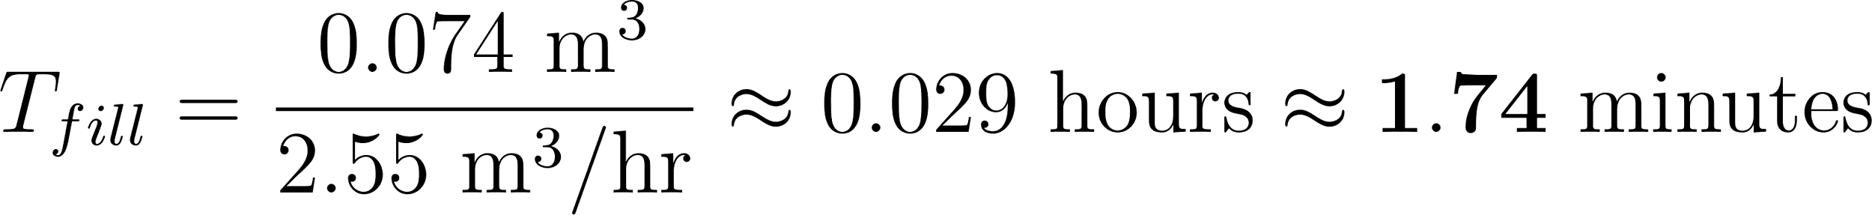
Conclusion:
A 4-Head unit can fill the entire tower with dense fog in under 2 minutes. This confirms the unit is powerful enough. We will likely run it on a Duty Cycle (e.g., 5 mins ON, 10 mins OFF) to prevent heat buildup.
3.4 Validation Plan
- "Dry Hand" Test: Place a hand in the mist stream. It should feel cool and damp but should not form running water droplets instantly.
- Temperature Check: Run the fogger for 30 minutes in 5L of water. Measure water temperature rise. If temp rises >5°C, we must increase the reservoir size or reduce the duty cycle to prevent cooking the roots.

4. Electronics & Control System Design
This section details the selection of the microcontroller ("the brain") and the power distribution network required to automate the rotation and misting cycles.
4.1 Decision Matrix: Microcontroller
We evaluated options based on Analog I/O (critical for pH/EC sensors), Logic Voltage (compatibility with relays), Cost, and Reliability.
Microcontroller | Analog Inputs | Logic Voltage | Reliability | Cost | Score (1-5)
Raspberry Pi 4 | None (Needs ADC) | 3.3V (Low) | Medium (OS can crash) | High ($75+) | 3/5
ESP32 | High (But noisy) | 3.3V | High | Low ($10) | 4/5
Arduino Uno R3 | High (10-bit) | 5V (Standard) | Very High | Low ($25) | 5/5 (Selected)
4.2 Justification
- Arduino Uno R3: Selected because the HELIX system requires robust Real-Time Control rather than high processing power.
  - 5V Logic: Most industrial relays and budget pH sensor boards operate natively on 5V. The Arduino handles this directly, whereas an ESP32 or Raspberry Pi would require "Logic Level Shifters," adding complexity and failure points.
  - Analog Precision: The Uno has dedicated hardware Analog-to-Digital Converters (ADC) ideal for reading soil moisture or pH sensors, which the Raspberry Pi lacks entirely.
4.3 Computations: Power Budget & Sizing
We must size the 12V Power Supply Unit (PSU) to handle the peak inrush current when the motor starts.
Assumptions:
- System Voltage: 12V DC.
- Motor (JGY-370): Rated 0.2A (No Load), 1.2A (Stall/Startup).
- Arduino + Logic: 0.1A.
- Mister: Powered independently (AC Adapter), but controlled via a 5V Relay (Relay coil current ~0.07A).
Step 1: Calculate Total Peak Current on 12V Rail
- Formula: I_peak = I_motor_stall + I_arduino + I_relay
- Calculation:
I_peak = 1.2A + 0.1A + 0.07A
I_peak = 1.37 Amps
Step 2: Safety Factor (SF)
Standard electrical engineering practice suggests a Safety Factor of 1.5x for power supplies to prevent voltage droop.
- Required Current: 1.37A * 1.5 = 2.055 Amps
Conclusion:
We require a 12V 2A (24W) Power Supply. A standard 12V 1A adapter is insufficient and would likely cause the Arduino to reset whenever the motor starts (Brown-out).
4.4 Validation Plan
- Brown-out Test: Program the Arduino to turn the Motor ON/OFF every 2 seconds. Monitor the 5V pin on the Arduino with a multimeter. If voltage drops below 4.5V, the power supply is too weak.
- Sensor Calibration: Immerse pH and EC sensors in standard calibration fluids (pH 4.0 and 7.0) to generate a calibration curve before deployment.
- Fail-Safe Test: Unplug the Rotation Motor. The system should detect the fault (via encoder or current sensor) or simply continue misting. The plant life takes priority over rotation.

